February 18, 2025 | Bimasakti 11 - HandOver
 |  | Business Process

Document Control

Tanggal | Versi | Perubahan | Keterangan

Daftar Isi
1 Input eForm via Tenant Apps 3
2 Checklist eForm 6

HandOver
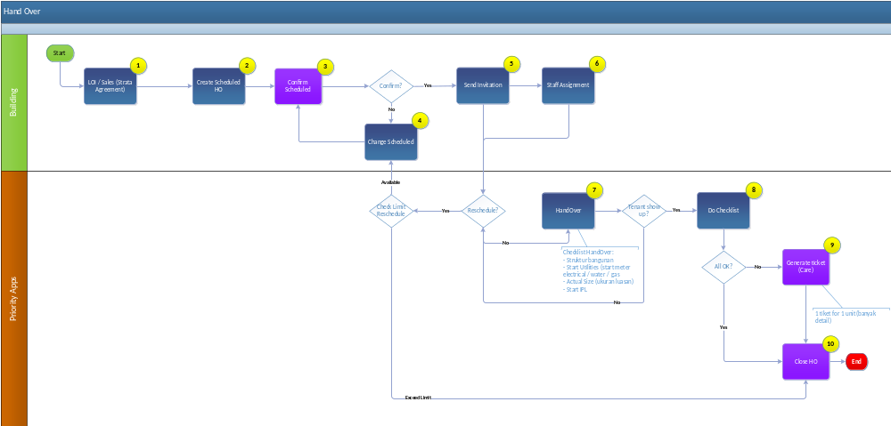
PROCESS DESCRIPTION:
NO | PROCESS | DESCRIPTION
1 | LOI/Sales (Strata Agreement) | Process :  - Terbit Strata Agreement  Input :  - Strata Agreement  Output :  - Submitted Strata Agreement  User :  - Tenant, Sales
2 | Created Scheduled HO | Process :  - Created Scheduled HO berdasarkan Strata Agreement  Input :  - tanggal HO  Output :  - Scheduled HO  User :  - Sales / Admin
3 | Confirm Scheduled | Process :  - Mengkonfirmasi schedule HO dengan tenant  Input :  - Scheduled HO  Output :  - Scheduled HO yang sudah di konfirmasi  User :  - Tenant, Sales
4 | Change Scheduled | Process :  - Mengubah tanggal HO sesuai kesepakatan dengan tenant  Input :  - Tanggal HO  Output :  - Scheduled HO  User :  - Sales / Admin
5 | Send Invitation | Process :  - Mengirim email invitation untuk HandOver  Input :  - Scheduled HO  Output :  - Email Invitation HandOver  User :  - Sales / Admin
6 | Staff Assignment | Process :  - Assign Staff untuk process HandOver  Input :  - List Staff untuk process HandOver  Output :  - Assigned HandOver Staff  User :  - Sales / Admin
7 | HandOver | Process :  - HandOver dengan tenant  Input :  - Checklist HandOver  Output :  - Checklist HandOver  User :  - HandOver Staff
8 | Do Checklist | Process :  - Process checklist handover  Input :  - Checklist HandOver  Output :  - HandOver yang sudah terchecklist  User :  - HandOver Staff
9 | Generate Ticket | Process :  - Generate tiket Care jika ada masalah saat HandOver  Input :  - Checklist HandOver  Output :  - CARE No  User :  - HandOver Staff
10 | Close HO | Process :  - Close HandOver  Input :  - Checklist HandOver yang sudah selesai  Output :  - HandOver Status = Closed  User :  - HandOver Staff

